**Simplified Reference Tissue Model (SRTM) for PET Receptor Studies**

**Full Reference Tissue method**

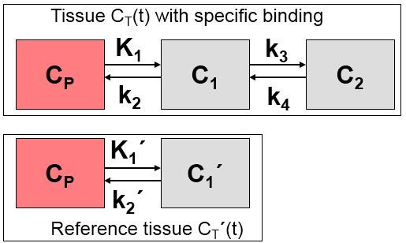

C_Model(t) = R_1 { C_T‘(t) + aC_T‘(t)(*)exp[-ct]+ bC_T‘(t)(*)exp[-dt]}

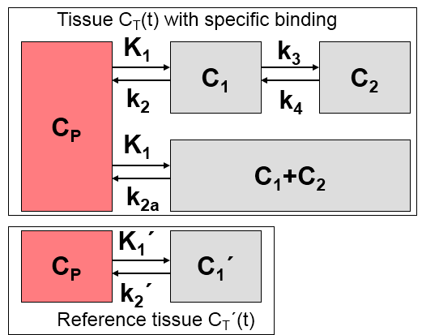**vs. SRTM**

Defining

R_1=K_1 / K_1‘

C_Model(t) = R_1C_T‘(t) + {k_2 – R_1k_2 / (1+B_NP)}C_T‘(t) (*) exp[-k_2t/(1+BP_NP)]

Assumptions:

distribution volume is the same for the tissue of interest and the reference volume:

K_1/k_2 = K_1‘/k_2‘

tissue TAC can be fitted by a 1-tissue compartment model

Unknowns:

R1, k2, BP_ND

k_2‘ and k_2a are provided